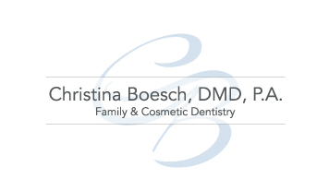

TREATMENT PICTURE CONSENT

I, __________________________, give permission for the doctors and staff of Christina Boesch, DMD, P.A. to:

(please initial your authorization on each line)

___________ I authorize Christina Boesch, DMD, P.A. to take photographs/video or by other similar means record my treatment procedures. I understand that reproduction or publication of said photographs and recordings will be used for the purpose of improving my overall dental care, communication with a dental laboratory, for dental and/or scientific study and research, education, before and after surgical portfolios and/or documentation for my dental record.

____________ I understand that the photographs and recorded material may include appropriate portions of the mouth, head, face and neck to demonstrate surgery/procedures and every effort will be made to protect the patient’s identity in those materials. I further acknowledge that all recorded media obtained is the sole property of Christina Boesch, DMD, P.A.

____________ I waive all rights that I may have to any claims for payment or royalties in connection with any exhibition, televising, or other showing of the photographs/video regardless of whether such use of said photographs/video is commercial, institutional or private sponsorship, and irrespective of whether any fee or charge is received by Christina Boesch, DMD, P.A.

____________ I give Christina Boesch, DMD, P.A. permission to use full face photos/video for before and after portfolios, website publication, brochures, marketing material, and televising and other uses.

I hereby certify that I have read the forgoing consent and fully understand the contents thereof.

_____________________________ _________________
Patient Signature Date

